You need to review the subject and style terms that were discussed in chapter 2. For example the subject in image A is no subject and the style is non-representational. The style of image B is abstract and the subject would be a portrait. For part B when you are discussing art elements you need to explain and give examples of where and how the elements are used in the work of art. Remember the elements are: line, shape, form, color, value, texture and space. For part C you need to review the principles of design. They are: balance, contrast, emphasis, rhythm, pattern, movement and unity. Part D should be based on a art term they have in common like and element, principle, subject or style.

Name
ART 100
Open Response
A. 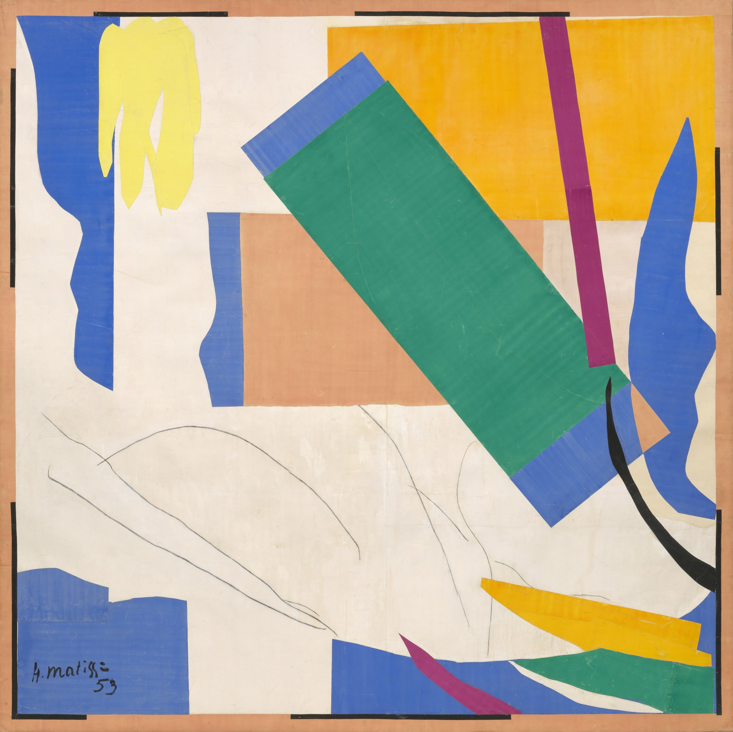 | B. 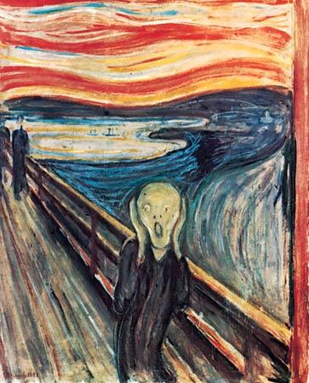

Answer the following questions as completely as possible.

- List the subject and style for image A and B.
- Describe in detail two art elements used in image A and B.
- Describe in detail one art principle found in image A and B.
- Compare image A and B and find one art term that they have in common.

